**CMSC203 Assignment 0**

Class: CMSC203 CRN 38511

 Program: Assignment 0

Instructor: Grigoriy Grinberg

 Summary of Description: (Give a brief description for each Program) A file that contains the programs referenced to within this document via the screenshots.

 Due Date: 01/31/2022

 Integrity Pledge: I pledge that I have completed the programming assignment independently.

 I have not copied the code from a student or any source.

**Complete the following five parts of Assignment 0. Name your file as FirstInitialLastName_Assignment0.docx**

**Part1: Setup GitHub:** Provide the screen shots of your GitHub account with Assignment 0 file is uploaded on GitHub:

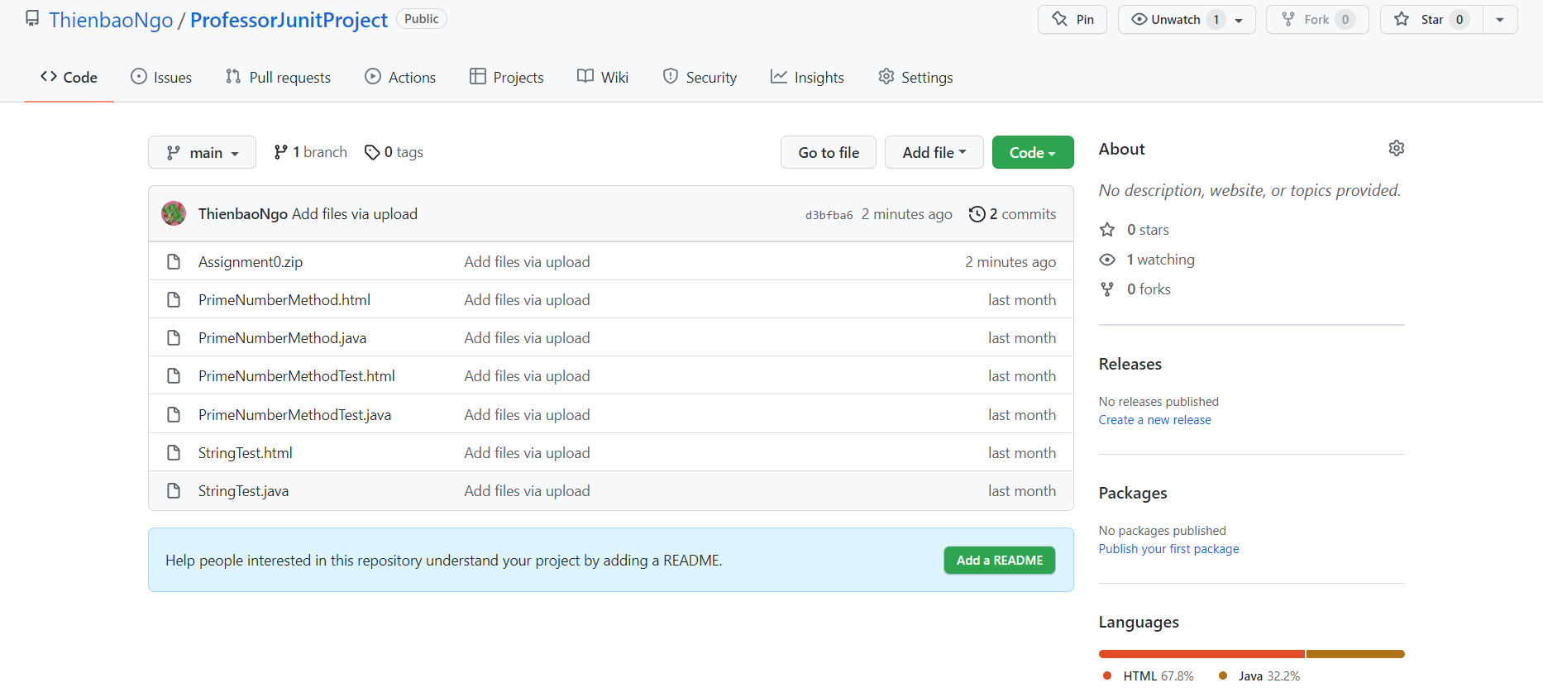

**Part 2 -Install JDK, Test java Application from Command Line**

Provide the screen shots from Step 1 and 2 here:

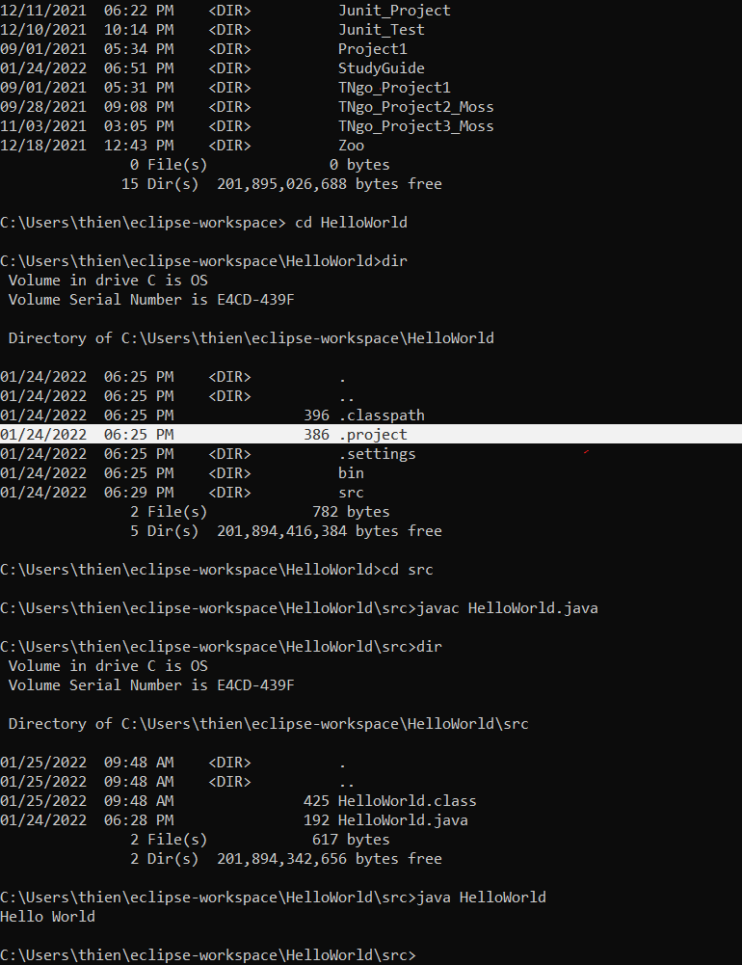

**Part 3 - Install Eclipse, Test Eclipse Java Application**

Provide the screen shots from Step 1 and 2 here:

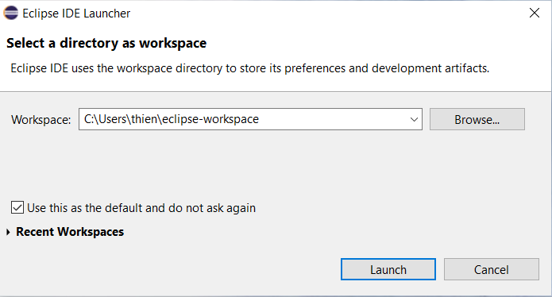

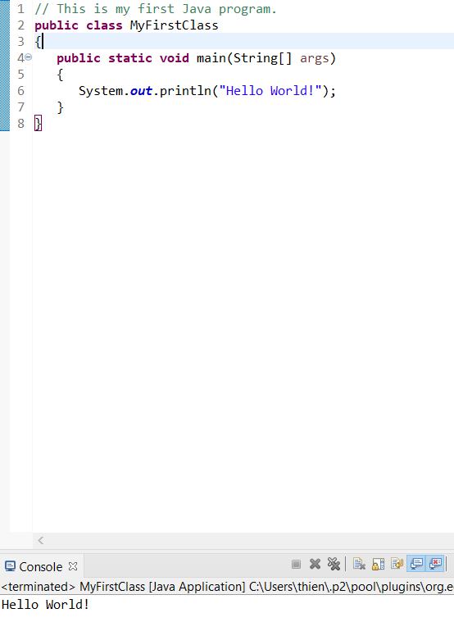

**Part 4 - Install, Setup, Test Junit Program.**

Provide the screen shots showing:

* 1. Project screenshot

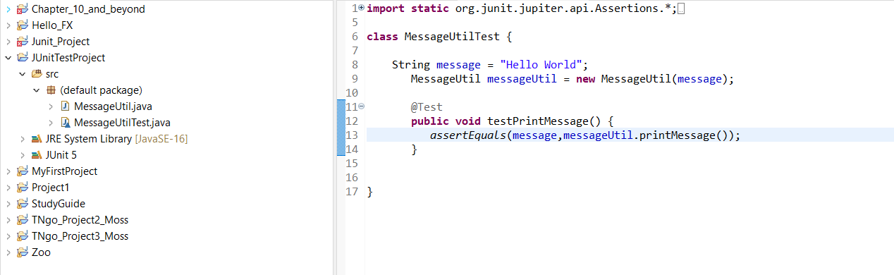

* 1. Eclipse with working JUnit Test example/Running example screenshot

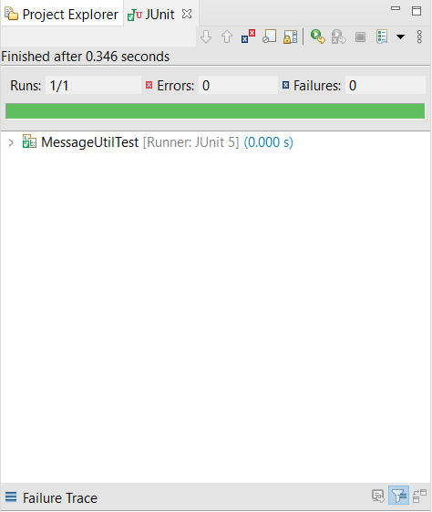

**Part 5 - Install, Setup, and Test JavaFX Application.**

Professor, I am unable to provide you the proper screenshots for the Java FX portion of my project, because while I was trying to get your class file working, Java FX broke on my IDE. I cannot get it working anymore, my VM arguments are the same, and I tried everything to get it working right. I basically spent an entire day trying to get it working to no avail, including one hour in tutoring. You can ask Todd (tutor 0151) about the details about what’s happening to me. As such, I am just going to put back the old screenshots I did for this portion. I will message you soon later as to what to do about this- if I can get more time, or if not, just find out what the heck is going on.

PS, the reason I didn’t know about the parts 1-5 documents, was because I actually started working on this project before you uploaded them to the zip file, so I only had the submission template.

Provide the screen shots showing:

1. JavaFX Project screenshot

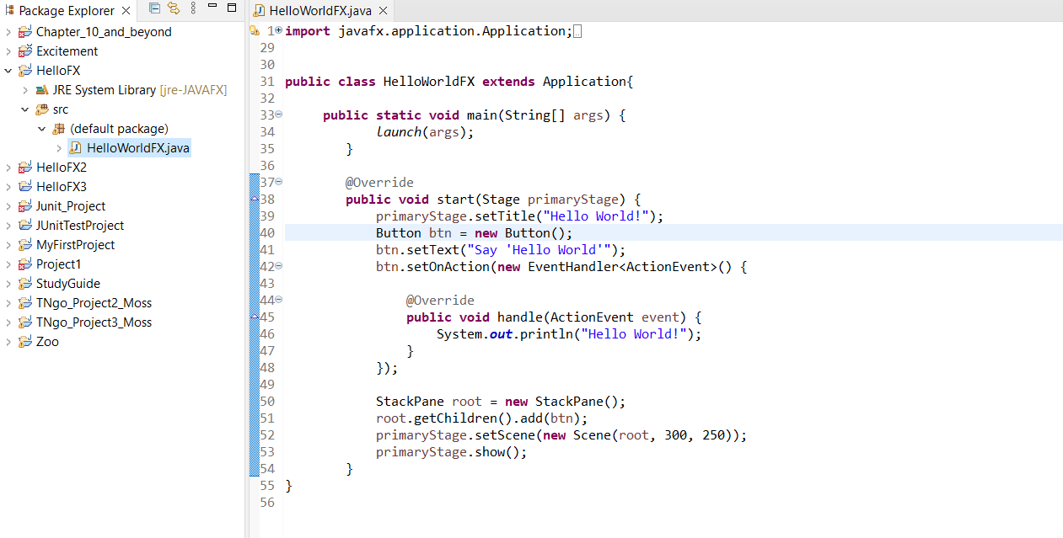

1. Java Source Code File

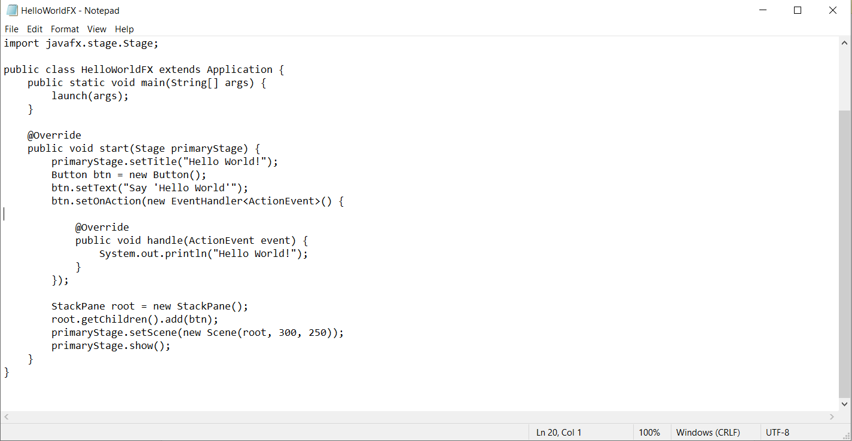

1. Running example screenshot

**(BROKEN RESULT)**

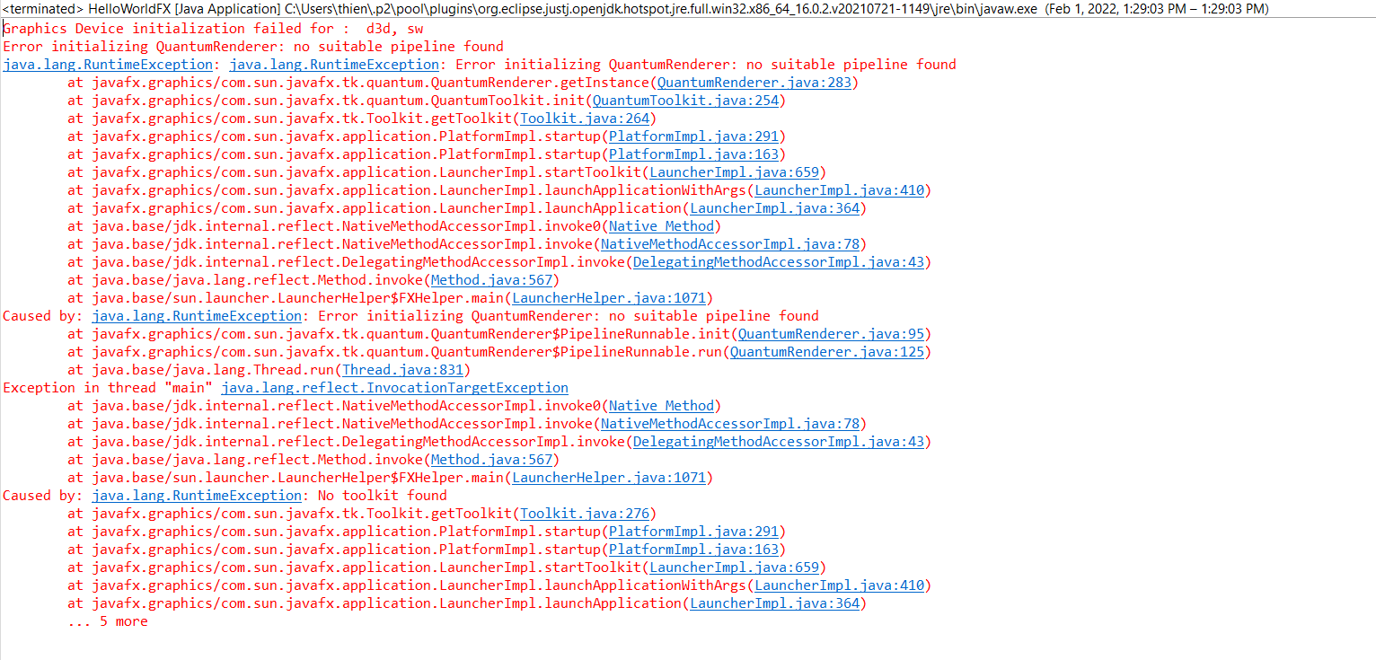**(OLD SCREENSHOT)**

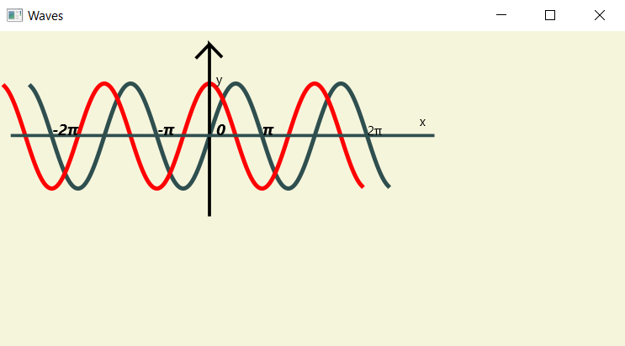

**(This following document and it’s screenshots was uploaded to GitHub.)**

**Lessons Learned** <Provide answers to the questions listed below>**:**

Write about your Learning Experience, highlighting your lessons learned and learning experience from working on this assignment.

What have you learned? I didn’t really learn much as most of this is stuff I’ve already went over, however it’s still always nice to review.

What did you struggle with? For some reason my JAVA_HOME variable deleted itself over the break, as well as my JavaFX virtual machine arguments, so that was weird.

What parts of this assignment were you successful with, and what parts (if any) were you not successful with? I’m glad I could fix those small errors before they could really frustrate me, however for some reason I cannot get JavaFX and Junit working in the same project.

Provide any additional resources/links/videos you used to while working on this assignment. n/a.

**Check List:** <Provide answers to the column Y/N or N/A >**:**

|  |  |  |  |
| --- | --- | --- | --- |
| **#** |  | **Y/N** | **Comments** |
|  | **Assignment files:** |  |  |
|  | * FirstInitialLastName_Assignment0.docx/pdf | **Yes or No Y** |  |
|  | * Source java files | **Yes or No Y** |  |
|  | **Program compiles** | **Yes or No Y** |  |
|  | **Program runs with desired outputs related to a Test Plan** | **Yes or No Y** |  |
|  | **Documentation file: Screenshots of** |  |  |
|  | * Part1: Setup GitHub | **Yes or No Y** |  |
|  | * Part 2 -Install JDK, Test java Application from Command Line | **Yes or No Y** |  |
|  | * Part 3 - Install Eclipse, Test Eclipse Java Application | **Yes or No or N/A Yes** |  |
|  | * Part 4 - Install, Setup, Test Junit Program | **Yes or No or N/A Yes** |  |
|  | * Part 5 - Install, Setup, and Test JavaFX Application. | **Yes or No or N/A Yes** |  |
|  | * Lessons Learned | **Yes or No Yes** |  |
|  | * Checklist is completed and included in the Documentation | **Yes or No Yes** |  |